**Name ___________________________________________ Date __________________**

1. 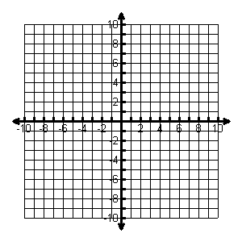
2. 
3. 
4. 
5. 
6. 



1. 
2. 

**Using  as a guide, describe the transformation.**

1. 
2. 
3. 
4. 
5. 
6. 

**Use the description to write the square-root function g.**

1. The parent function ****is compressed vertically by a factor of 1/3 and then translated 3 units left.
2. The parent function is reflected across the y-axis, stretched horizontally by a factor of 6, and then translated 2 units right
3. The parent function ****is reflected across the x-axis and then translated 1 unit left and 4 units down
4. The parent function ****is reflected across the y-axis, vertically stretched by a factor of 7, and then translated up 5 units